Market Requirements Document (MRD)
For Objet Triplex

Document Revision History:

Date | Revision | Main modifications | Revised By | Approved By
22/09/2010 | A |  | Roee Reshef | Igal Zeitun
1/12/2010 | B |  | Roee Reshef | Igal Zeitun
20/01/11 | C |  | Roee Reshef
15/6/11 | 5 | - BOM increase of Triplex reduced to $500 instead of $6,000 to support the vision of having Triplex as the single HW platform supporting Eden, Connex and Triplex  - Removed SHQ from the must items for Triplex  - Modification of Packages naming in Section 3.2  - Added Appendix A to describe the Advanced licensing included in Triplex  - Added batch traceability requirement | Roee Reshef | Igal Zeitun
23/6/11 | 6 | - NFPA standard requirement removed.  - Helios-B material removed.

Table of Contents

Executive Summary

The RP industry is traditionally segmented into 4 main segments: form & visualization, fit and assembly, functional RP models and Functional end-use parts. The last 2 segments, requiring high-grade engineering materials represented 50% of the applications in 2009 and are in constant growth the last years.
Due to its limited current offering in high-grade materials, Objet penetration of the functional segments is low compared to the industry and to the competition.
SLA, SLS and FDM technologies are today well beyond Objet in terms of material properties and in terms of the variety of materials simulating engineering materials (ABS, PP, PE and more).
A Triplex product, based on the high-quality proven Connex platform but expanding Connex technology to allow simultaneous jetting of up to 3 building materials is defined in this document. Such a product will significantly improve Objet offering in terms of high-grade functional materials and will therefore increase Objet competitiveness in the high-end functional segments.
On top of high-grade materials, Triplex will open more opportunities for complex mixed trays and mixed parts in addition to the capabilities offered by Connex today.
This study will show that the overall yearly incremental business potential for a Triplex product can be conservatively quantified to more than $20M within 4 years following the product release.
The following table summarizes the technical specifications described in details in the present document.

Specification Summery
This chapter is aiming to summarize the system specification and is not replacing the detailed specification as in the MRD.
Characteristic | MUST | Required | Notes
Triplex Pro Package | X |  | This package will allow jetting of 3 building materials to create 1 composite model material for functional applications. A first generation package of 2 basic materials is defined as must for Triplex.
Printing speed | X |  | Same as current platform speed.  specified in Table 7
Printing speed Future compatibility |  | X | Not requested for the first release.  While high-speed heads concept is defined, R&D will be required to present timetable for high-speed introduction in Triplex product.
Triplex Multi-Material Package | X |  | This package will allow jetting of 3 building materials to create mixed parts and mixed trays.
Triplex Quality Package |  | X | This package will allow jetting of a combination of model and support materials allowing lower mixed layers effect on the final model
Platforms | X |  | Triplex technology should be implemented in the following platforms (per order of priority):  Objet500, Objet350, Objet260 & Objet1000
keep the original build size of the platform | X |  | Triplex will keep the original build size of the platform
Printing modes | X |  | Triplex will print in 3 modes: High-Quality, DM and High-Speed
Draft mode |  | X | Objet260-1000 should support the future draft mode
Printing quality: | X |  | Same as Connex according to the mode
Printing accuracy | X |  | Same as Connex - worst case of ± 300µ for the whole printing area, ± 100µ typical
Printing Roller Waste | X |  | Printing waste due to roller operation will be similar to Eden/Connex, around 20% of the gross input material.
Resin load in Eden mode | X |  | The resin load system should allow hot-swap for all the modes:
Resin load in DM mode |  | X | The resin load system should allow hot-swap for all the modes: not for the 260
Resin replacement waste |  | X | In worst case configuration of replacing Black material with White material in High-Quality mode, the overall resin replacement waste could be 10% higher than Eden, i.e. a total of up to 660 gr.  should be implemented if its not postponing the project in more than 6 months
Resin replacement time | X |  | Should be as in Connex, 3 hours in high-performance mode and 40 minutes in economy mode
Future upgrades/accessories |  | X | Compatibility for external “Juke Box” accessory for multiple resin management
Connex/Eden upgrade | X |  | Triplex should be designed such that Eden/Connex could be upgraded to Triplex with a BOM of up to $8,000 and in up to 5 days including training.
Machine dimensions and weight |  | X | Similar to Connex
Operating environment | X |  | Temperature range: 20-26 C  (maximum room temperature 29 c)  Relative humidity 20-50%
Machine external design | X |  | According to Objet new portfolio
Regulation compliance | X |  | FCC, CE, - machinery – mandatory  UL – should be done “on site  Power 220/110/100 V
RFID protection | X |  | RFID should protect the system from customer abuse and block usage of past-due cartridges as well as reuse of an empty cartridge. Blocking threshold should be put at 115-120% of cartridge volume.
Infrastructure to Multiplex |  | X
User Interface | X |  | Simplify the user interface as described in the MRD.
Reliability and Customer Support requirements | X
BOM |  | X | Can be up to $500 above Connex
MTBV | X |  | First year after release: 80 days (4.5 visits per year).  After 1 year: 120 days (3 visits per year).
Post Curing |  | X | System should support post curing that would take place inside the system in an “Oven Like” procedure.
Beta tests timing |  | X

Introduction

The Market Requirements Document (MRD) describes the Objet Triplex market opportunity, market segment and technical requirements.
It has to be noted that Objet Triplex is a subset of a Multiplex Objet 3D printer able to print with more than 3 different materials and/or multiple colors.
However, the present document is in purpose limited to Triplex market opportunity analysis and technical requirements, in an effort to make the minimal changes required on Connex technology to reach triple material jetting capabilities and prepare a minimum infrastructure for Multiplex future products.

The information in this MRD is base on:
- Yearly customer surveys performed by Objet on a sample of close to 1,000 Objet customers in 2009 and 1,200 customers in 2010
- Econolyst reports on Objet low-end and high end market opportunity
- Terry Wholers reports (2008 and 2009)
- Competitive analysis through public knowledge base

Business Objectives

Market Background

The Additive Manufacturing (AM) market place can be segmented into four distinct application groups based on these differing levels of machine capability. These application groups being (1) form & visualization models (2) fit and assembly models (3) functional RP models (4) Functional end-use parts. It is widely accepted by users that low end machines will not have the technical capabilities of high-end machines. However, a high-end machine will in most cases exhibit or exceed the capabilities of a low end machine.
Figure 1 show a schematic description of the AM market segmentation into the four groups [3].

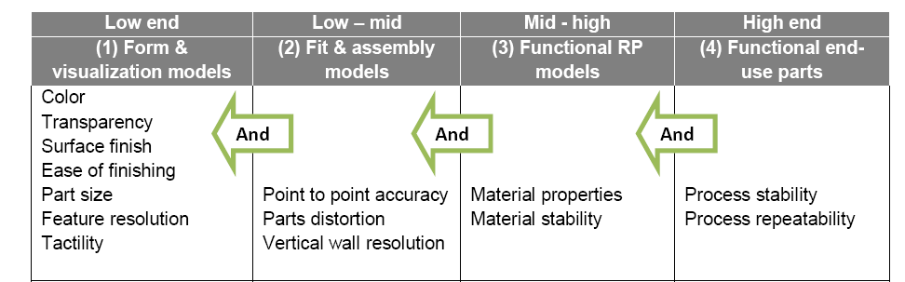
Figure 1: segmentation of AM market into 4 groups [3]

According to 2010 Wholers report [2], Form and Visualization applications stands for 25% of total AM applications, Fit and Assembly 13%, Functional models applications (including tooling and casting) 32% and End-use parts (Direct Manufacturing) stands for 15% of the total AM applications as shown in Figure 2.

. 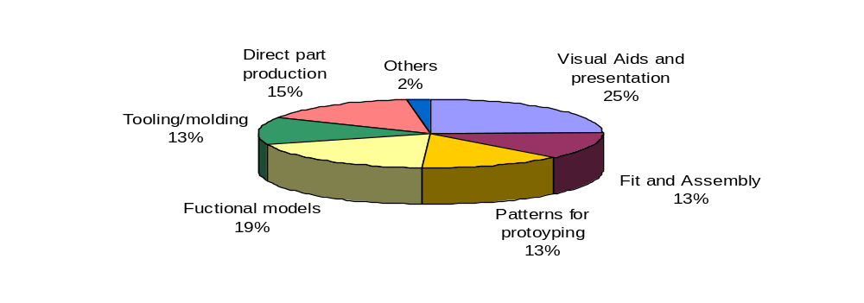
Figure 2: Application distribution within AM [2] in 2009

It is clearly seen that High-End Functional and Direct part production applications requiring high-level Material properties and stability are a main part of AM applications today (close to 50% in total). Wholers report estimation is that the AM market is moving towards more and more Functional and Direct Manufacturing application and so is the product offering in the market.
According to Objet 2009 customer survey [5], the profile of Objet customer’s application is quite different from the one describing the entire industry shown in Figure 2. According to this survey, the daily usage of Objet customers is mainly focused on Visual aids, presentation models and fit and assembly rather than real functional applications. According to this survey less than 30% of surveyed customers defined the high-end functional, direct parts and tooling applications as the main usage for their Objet equipment.
Those 30% functional applications compared to close to 50% estimated in the whole AM industry indicate a clear shift of Objet current users towards lower-level basic prototyping applications compared to the market trends and needs.
From the same survey (see Figure 3), it appears that the most important factor needed in future Objet system was defined as better material properties (23.3% of customers), well before lower price resins (17.4%) and faster printing process (15.1%).

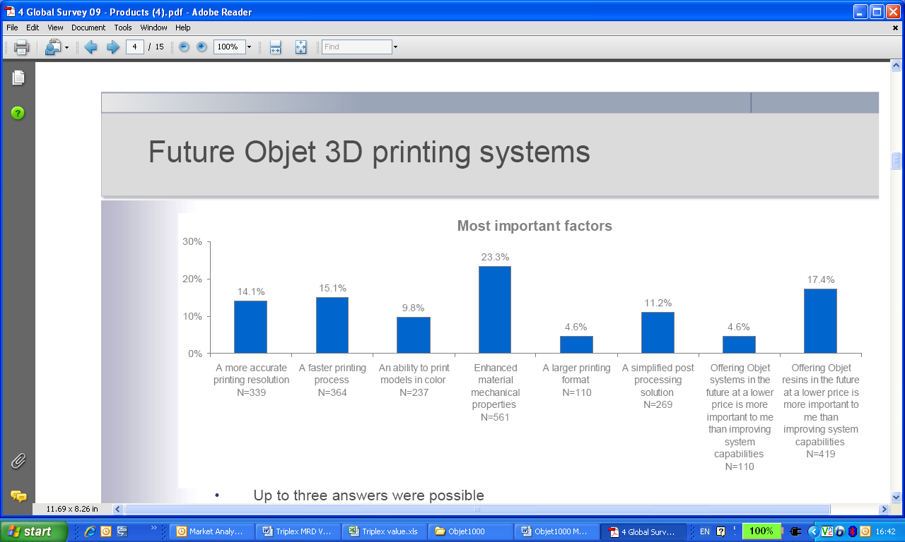
Figure 3: most important factors needed in future Objet system, according to 2009 Objet customer’s survey.

Even more extreme figures appear in the 2010 survey [6] where a total of 37% of surveyed customers described material properties or stability as the most important future needs of Objet printers (see Figure 3b).

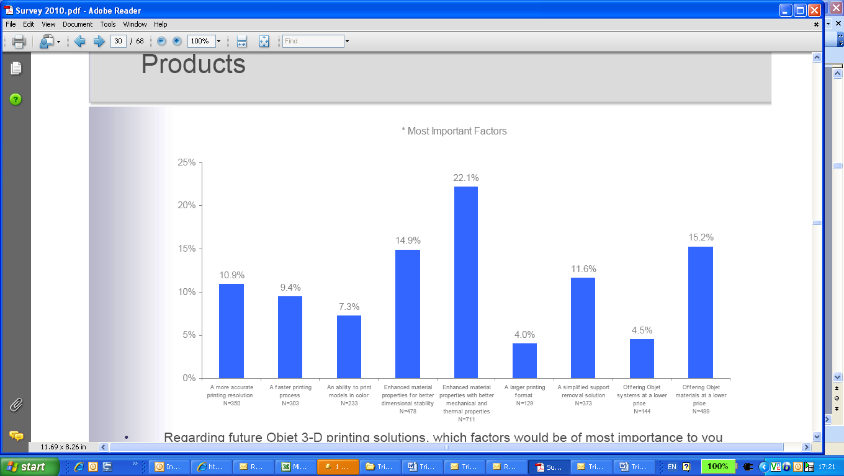
Figure 3b: Most important factors needed in future Objet system, according to 2010 Objet customer’s survey.

It appears clearly from the above figures that in today’s Objet offering, material properties is the main limitation for Objet to penetrate high-end functional applications at a rate equal or better to the industry and the competitors.
A dedicated analysis made on potential growth for Objet high-end products [3] shows very similar findings. According to this analysis, in order for Objet to significantly increase its market share and be attractive for more market segments and applications, there is a clear need to develop best-in-class AM materials with attractive cost of parts.

Best-in-class AM materials will be the main value proposition developed in the current requirement document for Triplex.

  - Competitive landscape

Figure 4 shows the actual competitive offering in the different AM segments defined according to Econolyst report [4]. Although quite subjective, this representation shows the main competitive players and their perceived functionality.

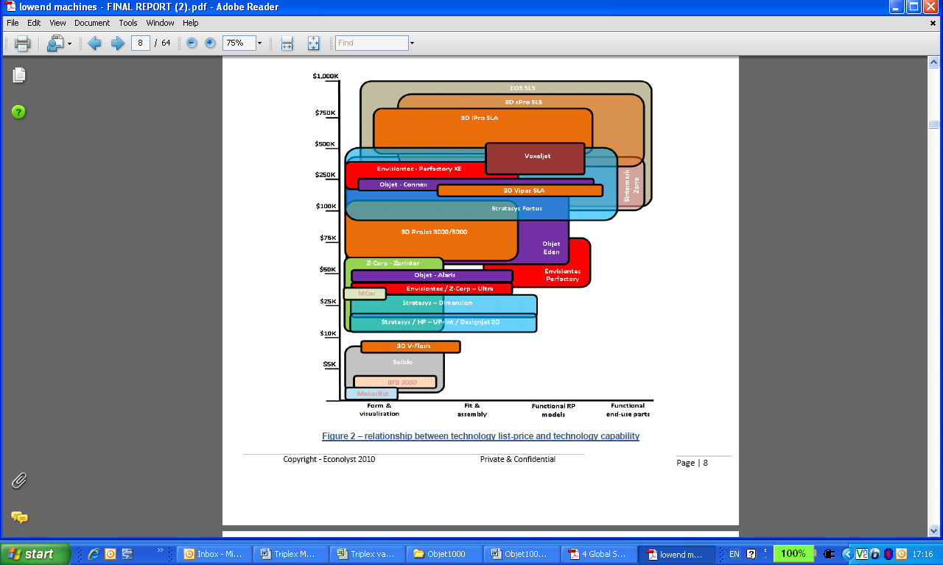
Figure 4: competitive landscape in the different AM segments [4]

In our current competitive analysis we will focus on the high-end segment starting from $100K and above and on equipment/technology showing clear capabilities of printing high-end functional and end user models. Namely, we will relate to Stratasys Fortus, 3D System Viper, EOS EOSINT representing the 3 leading high-end technologies, respectively FDM, SLA and SLS.

4.2.1 Stratasys Fortus

Fortus is a Stratasys product based on FDM technology.
The product is positioned as heavy-duty RP machine able to print real parts based on production-grade thermoplastics for conceptual, functional, manufacturing and end-use part applications.
The product is sold in 3 different models: Fortus360mc, Fortus400mc and Fortus900mc mainly differentiated by build volume size and materials capabilities.
Pricing of the printers varies from $80-150K for Fortus360mc, $100-250K for Fortus400mc and $350-500K for Fortus 900mc.
The below data sheet describes the main system configuration for Fortus400mc.
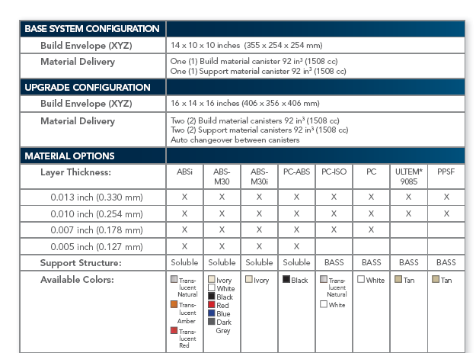

The main strengths of Fortus are:
- Good material properties and stability
- High reliability (heavy duty machine)
- Relatively low cost of parts
The main weaknesses of Fortus are:
- Relatively low tactility or surface quality
- Relatively low productivity
- Non isotropic on x/y vs. z planes

4.2.2 3DS Viper
Viper is a 3D system product based on SLA technology.
The product is positioned as an affordable SLA system ensuring application versatility while printing superior quality parts for prototyping, injection molding and investment casting applications.
The product is sold at a price point of $185-220K.
The following data sheet describes the main specification of the only model offered for Viper.
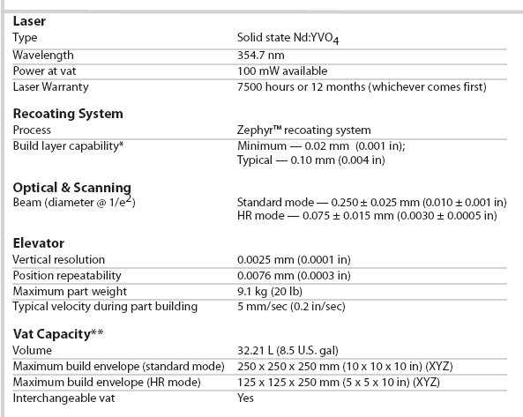

The following data sheet describes the SLA materials offering for 3D system .

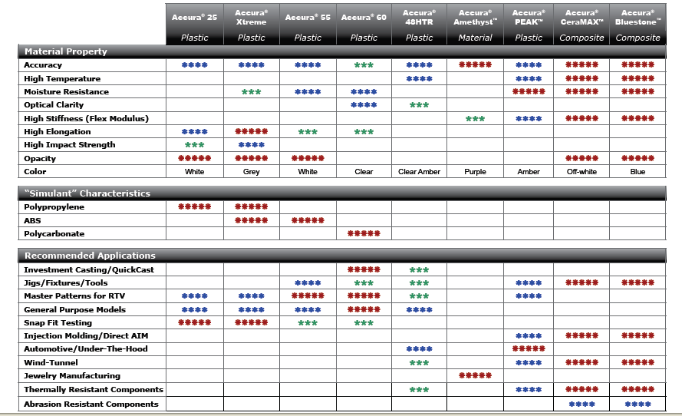

The main strengths of Viper are:
- Good material properties and stability
- Wide materials variety
- Relatively low cost of parts
- Excellent print quality
The main weaknesses of Viper are:
- Lower productivity than Objet (geometry dependant)
- Low user-friendliness
- Low versatility (although the product is positioned differently)
- Industrial system

4.2.3 EOS EOSINT
EOSINT is EOS product based on SLS technology. The product is offered in 3 basic configurations: Plastic SLS, Metal SLS and Sand SLS. Since the 2 last models are out of our current competition scope and are offered at very high prices (more than $500K and up) we will focus on EOSINT P models offering Plastic SLS.
The product is positioned as highly productive SLS system printing fully functional plastic models for use in direct manufacturing and functional models.
EOS Plastic SLS is sold in 4 different models priced from $200K for the entry level (Formiga) to above $1000K (EOSINT P 800).
The following data sheet describes the main specification of the mid level model, the EOSINT P 395.

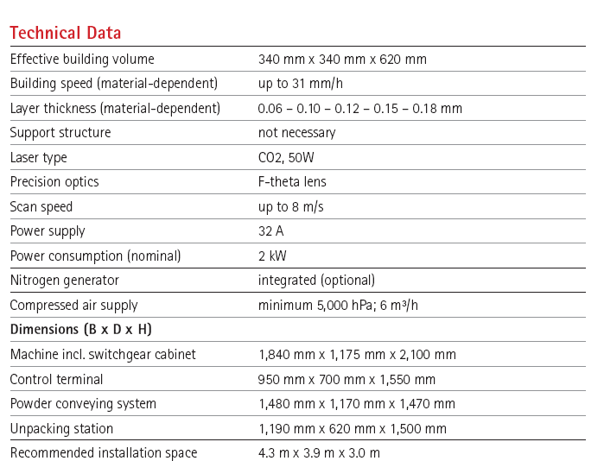

The following table describes the range of materials offered on EOSINT machines.

Material | Applications
PA 2200 | Functional prototypes
PrimePart | Functional prototypes, end products, spare parts
PA 2210 FR | Flame resistant parts
PA 3200 GF | Housings and thermally stressed parts
Alumide | Metallic appearance
PrimeCast 101 - Polystyrene | Master patterns for vacuum casting.
CarbonMide | Wind tunnel tests or aerodynamic app.

The main strengths of EOS are:
- Excellent material properties and stability
- Low cost of parts
- Good parts quality and finish
- Heavy duty machine
- Good print quality
The main weaknesses of EOS are:
- Lower productivity than Objet (geometry dependant) taking into account the very long cooling time involved in SLS process.
- Low user-friendliness
- Low versatility
- High equipment price
- Industrial system

4.2.4 Summary of competitive landscape

In order to make a simplistic general competitive comparison between the different products and Objet offering, we assumed that the top5 criteria for the high-end segment are: Material properties, Print Quality, Cost of parts, Reliability and Productivity.
Using the above data on high-end competition, Figure 5 shows the value profile of each of the 3 products discussed above compared to current Objet Connex product.

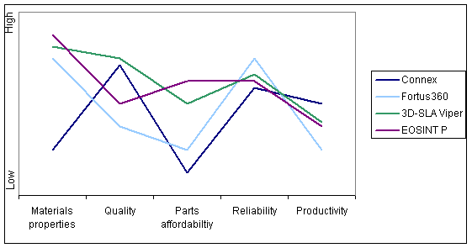

Figure 5: schematic competitive comparison between Connex and other main high-end products

The main gap for Objet compared to the competition high-end offering is in material properties. The second gap is in Cost of parts that is worse than the rest of the industry. For the rest of the parameters Objet is as good or better than the other high-end products.

Market Opportunity

The previous sections showed that the main problem Objet is facing in the high-end arena, is the limitation of Objet materials to reach high-end Functional applications that are today the majority of AM customers applications and are going to be more and more dominant in AM future applications.

Triplex technology expands the Connex capabilities to print models with a total of 4 materials (support and model materials).
Based on the above market study, we see several important market and business opportunities for a Triplex machine:
A. The main market opportunity would be the penetration of high-end functional applications by offering a significant improvement in material properties and a choice of materials simulating high-level engineering materials (both solid and flexible) while keeping the main Connex advantages: parts quality, speed and multiple material printing.
B. The secondary market opportunity for a Triplex 3D printer, is an offering of higher surface quality and stronger models by improving the mixed layers effect in the interface with support materials. It is assumed that a complex support structure using dual support jetting capabilities will allow improving the mixed layer interface without impacting the support properties.
C. The tertiary market opportunity for a Triplex 3D printer is improved mixed parts and mixed trays capabilities. Using 3 model printing materials will allow building of triple material composite parts (e.g Clear, Opaque and Tango) or trays with models each of which made of 3 different materials.

Figure 6 shows the Triplex competitive profile assuming a major improvement in building materials and mixed parts/trays capabilities as well as slight reliability improvement. This profile is highly more competitive than the current Connex profile and will allow better penetration and higher market share in high-end segments.
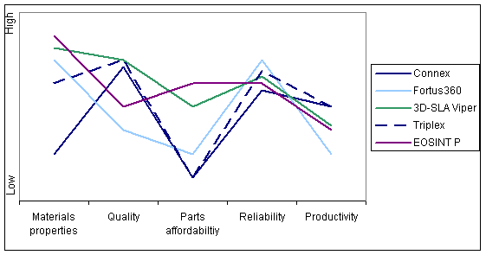

Figure 6: Competitive profile of Triplex compared to main competition and Connex

Business Objectives

According to Wholers 2010 report [2], it can be estimated that around 900 high-end machines were sold during 2009. Table 1 below shows the estimated distribution of high-end systems sales in 2009 derived from Wholers report.

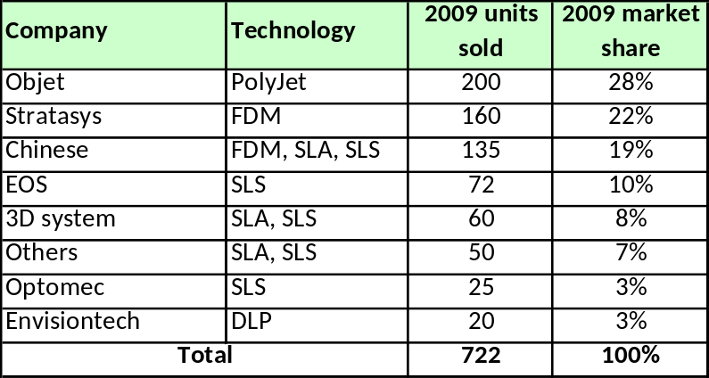
Table 1: Distribution of high-end AM units sold in 2009

Assuming the following:
- Triplex introduction will improve the competitive advantage of Objet in the high-end and will fill the existing gap in material properties while keeping the other leading advantages of Connex
- Triplex pricing will be above current Connex pricing and in the range of the high-end FDM and SLA machines (see Section 2.5).
- Following Triplex launch, Connex will be upgradable to Triplex
- Competitors will continue to develop better materials and more performing printers filling the gaps in model quality and productivity compared to Objet.
- Triplex is not going to compete with very high-end machines like Metal SLS .
- 8% YoY growth of the high-end market [5].
- Triplex resin consumption will be at least equal to Connex consumption.

We can safely estimate that within 3 years of the launch, Triplex will enable more penetration in the Functional applications segments and shift the 30% functional applications of today’s Objet customers towards the standard 50% of the industry (see Section 4.1). This shift can be translated into 5-6 pts market share gain of the high-end market. This will come from both taking share from competition and attracting new segments and applications due to Triplex innovative capabilities.
On top of that, we can assume that due to the upgradability option and despite the natural cannibalization process, Eden/Connex units sales will grow as well by at least 10% within 3 years. Table 2 summarizes the business opportunity assumptions for the first 5 years after Triplex launch.

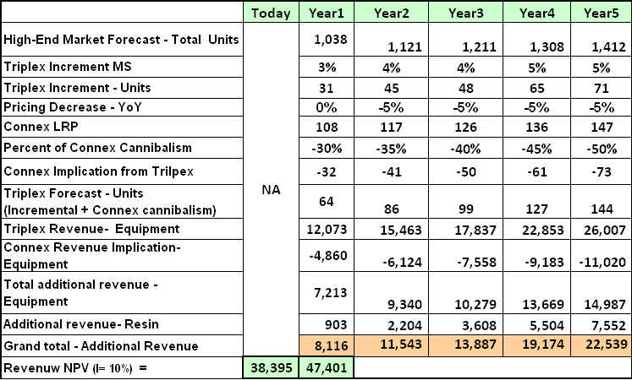
Table 2: Estimation of 5 years business opportunity for Triplex in 1,000 of US$

Table 3 describes the Objet LRP figures that were defined in 2008, for Triplex in both Equipment and resin. It has to be noted that in the first 3 years the figures are very comparable. However in years 4 and 5 our current estimation is more conservative than Objet LRP assuming an aggressive YoY growth of 47% and 33% in year4 and year5 for Triplex sales.

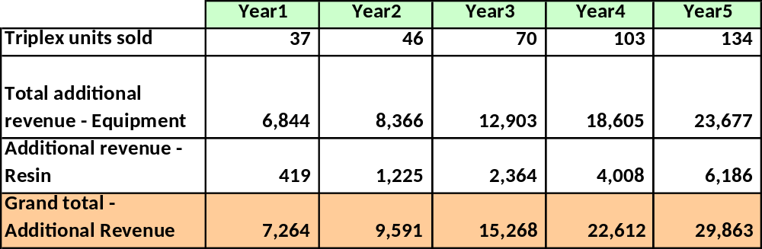
Table 3: LRP figures for Triplex Revenue projection in 1,000 of US$

Pricing targets

Since Triplex value will be in the same range as EOSINT P, Viper and Fortus360mc and higher than current Connex, the pricing should be one step above Connex while staying in the competition ballpark. Table 4 is the pricing sizing for each Triplex platform in US$.

 | Objet260 | Objet350 | Objet500 | Objet1000
Eden | 91,000 | 136,000 | 174,000
Connex | 145,000 | 200,000 | 240,000 | TBD
Triplex | 195,000 | 250,000 | 295,000 | TBD
Table 4: Primary sizing of Triplex pricing

Product Requirements

Value Proposition
The following summarizes the market analysis developed in the previous sections and defines Triplex high-level Value Proposition.

Customer Segment: High-end customers (service bureaus and companies) printing realistic prototyping, form, assembly and functional parts.
Customer Needs: Superior material properties, Wide choice of materials simulating engineering materials, high printing quality, high productivity and reasonable cost of parts.
Triplex Value Proposition:
- Enhanced material properties and variety enabled by triple material jetting technology
- Good combination of print quality, productivity and versatility of current Connex offering
- Better reliability and uptime than Connex in 2010
- 3 materials ready for printing with no resin replacement.

  - Detailed Technical requirements

3.2.1 Material packages
Starting from mid 2011, Objet offering will be split into 3 standard packages available for any of the Objet platforms.
A. Standard Package: Solution enabling to print a single prototyping simple material at a time.
B. Pro Package: Solution enabling the jetting of more than 1 building material to create a model made of composite functional material.
C. Multi-Material Package: Solution enabling full DM capabilities, mixed parts (overmolding) and mixed trays made of more than 1 material in the same model/tray.
All the 3 packages will be available on Objet260 to Objet500 platforms and later-on on Objet30 platform as well.
On top of the standard packages, other optional packages will be available as chargeable options for each of the standard packages like: Super High Quality mode, GreyScale, Draft Mode, …..
Triplex will follow the same principle and add more capabilities to the Functional and Advanced packages as well as add more optional packages. The following sections describes the main packages required for Triplex.

A. Triplex Pro Package:
This package will allow jetting of 3 building materials to create 1 composite model material for functional applications.
Using this 3 building materials, Triplex will allow simulation of higher-grade engineering plastics.
Table 5 below describes the first generation package of Triplex materials needed for Triplex launch.
A wider choice of materials should be allowed by Triplex technology and should be released along the life of Triplex. For each material, a specific MRD describing the whole material properties will be issued separately.

Material | Application | HDT (after PC) | N.I Impact | Elongation at break | Water absorp. | Tensile strength | Flextural strength
ABS150 | Dynamic | 130-150°C | 60-70 J/m | 40-50% | <0.7% | 35-45 MPa | 60-70 MPa
Table 5: First generation package of Pro materials for Triplex (reference)

B. Triplex Multi-Material Package:
This package will allow jetting of 3 building materials to create mixed parts and mixed trays made of 2 or 3 different materials as follows:
- 3 building materials printing trays made of 3 different simple materials. This option will allow higher productivity while printing mixed tray parts using 3 different materials with no resin replacement. This feature is today appreciated by the existing Connex users, specifically SBs or Corporate Bureaus that experience frequent replacement of resins per their end user application requirements.
- 3 building materials printing parts made of 3 different materials.
- 3 building materials printing parts or trays made of 2 different materials (1 composite and 1 simple). For example, the combination of rubber like material with advanced rigid material (for example ABS-Like) in a single part, for Overmolding usages or any simulation of multi martial parts.

C. Triplex Quality Package: (Optional package)
This package will allow jetting of a combination of model and support materials allowing lower mixed layers effect on the final model. This package requires use of 2 support materials and leaves 2 materials for the model building.

Table 6 summarizes the 3 main Triplex packages requirements.

Package | Model loading materials | Support loading materials | End model materials | Value
Triplex Pro | 3 | 1 | 1 | High material properties
Triplex Multi-Material | 3 | 1 | 2 or 3 | Mixed trays and mixed parts
Triplex Quality | 2 | 2 | 1 or 2 | Lower mixed layers
Table 6: summary of Triplex main packages

D. Future packages:
As a reference the below is a list of optional packages that should be available for Triplex along the Triplex life. It has to be noted that those packages are not must or required for Triplex launch: Peelable support package, Soluble support package, Cheap filler material package, Color package – 3 color printing, Grey-scale package, Improved rubbers package
,Dent package.

Appendix A describes the packaging and licensing requirements in more details.

3.3.3 Machine Technical specifications
- Platforms: Triplex technology should be implemented in the following platforms (per order of priority): Objet500, Objet350, Objet260 and Objet1000.
- Build size: Triplex will keep the original build size of the platform.
- Printing modes: Triplex will print in 3 modes: High-Quality, DM and High-Speed. SHQ mode should be introduced in a later stage, when available.
- Printing speed: as specified as in Table 7 (per head width)
 | High-quality | DM | High-speed | Draft mode
Objet260-500 | 12 mm/hr | 12 mm/hr | 24 mm/hr | N/A
Objet1000 | 24 mm/hr | 24 mm/hr | 48 mm/hr | 72 mm/hr
Table 7: Printing Speed of Triplex

Future compatibility -
  - Triplex compatibility to higher speed heads is out of the scope of this project until a clear path for higher speed concept is defined.
  - Objet260-500 should support the future draft mode.

- Printing quality: same as Connex according to the mode
- Printing accuracy: same as Connex - worst case of ± 300µ for the whole printing area, ± 100µ typical.
- Printing Waste: printing waste due to roller operation will be similar to Connex, around 20% of the gross input material.
- Resin load:
  - The resin load system should allow hot-swap for all the modes: DM modes (2 and 3 materials) and Eden mode
  - Resin replacement waste: in worst case configuration of replacing Black material with White material in High-Quality mode, the overall resin replacement waste could be 10% higher than Eden, i.e. a total of up to 660 gr.
  - Resin replacement time should be as in Connex, 3 hours in high-performance mode and 40 minutes in economy mode.
Resin cartridges in the machine will differ between 260 and 350/500 models due to size thus implicating hot swap and maybe amount of waste.
In Objet260 machine hot swap will be optional and will be supported by “Juke Box” that will be offered upon availability as an accessory. 7
- Future upgrades/accessories: external “Juke Box” accessory for multiple resin management – upon availability (separated MRD will be defined)
- Connex upgrade: Triplex should be designed such that Eden/Connex could be upgraded to Triplex with a BOM of up to $8,000 and in up to 5 days including training. Eden/Connex upgrade eligibility could be limited to “Triplex-ready” machines that will include some preparation for the upgrade. The upgrade could also include external feeding system if needed.
- Machine dimensions and weight: similar to Connex
- Operating environment:
  - Temperature range: 20-26 C (maximum room temperature 29 c)
  - Relative humidity 20-50%
- Post Curing Process – It is expected that in same cases and composite materials the model will not be full cured immediately after the printing process.
It would be voluble if the system will support such post curing that would take place inside the system in an “Oven Like” procedure.
This requirement will be furthermore evaluated along with the development and progress of the materials for Triplex.
- Machine external design: according to Objet new portfolio.
- Regulation compliance:
  - FCC, CE, - machinery – mandatory
  - UL – should be done “on site” as this machine is based on components from
Eden/Connex and which are not certified and according to the low forecast particularly for North America – All new modules and component should be UL certified.
  - Power: as Connex.
- RFID protection:
  - RFID should protect the system from customer abuse and block usage of past-due cartridges as well as reuse of an empty cartridge. Blocking threshold should be put at 115-120% of cartridge volume.
  - IP protection and licensing requirements as will be specified in a separated document.
- Infrastructure to Multiplex: Triplex design should prepare a basic infrastructure to Multiplex in terms of SW I/Os, SW modularity, data processing modularity and ink system conceptual design. This should allow certain modularity and an easier scale-up while developing Multiplex machines.
- HASP protection: the different packages (standard and optional) should be HASP protected.
- Batch Traceability: the number and expiration date of all resin batches used during the job should be written in one of the Embedded log files for tracking purpose.

3.3.4 User Interface – should be defined as part of OS 9.1 requirements.
Triplex capabilities of printing a total of 4 materials (including Support) will add complexity to the user when it comes to material combinations definitions. Therefore, there is a need for a special effort to simplify the user interface in one hand while keeping all the Triplex capabilities on the other hand.
Selection of the new compositions (digital materials) will be enabled in 2 ways based on the level of usage defined for the operator:
  - Basic - Pre defined Materials
A pre-defined set of digital materials, already tested and approved by Objet will be available for selection. This will be very similar to the existing Connex workflow.
  - Advanced - User defined Materials
Ability to compose and save customer’s own materials by defining the required properties: physical, mechanical and thermal. An advanced user interface will enable “automatically” the generation of customized materials, rigid and flexible. The Advanced User Defined Materials User Interface full definition appears in Appendix A of this document.

3.3.5 Reliability and Customer Support requirements
- MTBV
First year after release: 80 days (4.5 visits per year).
After 1 year: 120 days (3 visits per year).
- Warranty and service cost: like current EdenV (2010 figures).
- Service area: no limitation
- Installation and training time: up to 4 days for two engineers

COGS and BETA date

- Target BOM: can be up to $500 above Connex (upon system type)
- Beta tests timing – Q4 2011

Success Criteria

Mandatory requirements - cannot be compromised
- Triplex Pro (ABS-150 material) and Mutli-Material packages
- Printing waste
- Friendly user-interface
- RFID protection
- Reliability
- Upgradability
- Keep rest of the Connex values (Print Quality, Speed, accuracy,…)

Requirements that can be compromised
- Triplex Quality package
- Hot swap in DM mode
- Infrastructure to Multiplex
- BOM

Financial Data

NPV TBD

References
[1] Wholers Report, 2009
[2] Wholers Report, 2010
[3] Market development strategy for high value Polyjet technology, Econolyst, January 2010
[4] Objet Low end machine technology & market opportunity analysis, Econolyst, September 2010
[5] Objet Global Customers Survey, 2009
[6] Objet Global Customers Survey, 2010

Appendix A: Advanced Licensing Requirements for Triplex

- Triplex will have advanced licensing capabilities to allow different Material packages using the same HW platform.
- The licensing will be HASP protected.
- Customers will be allowed to upgrade their HW with more advanced packages.
- In the long term, Triplex should have licensing capabilities covering the whole range of Objet high-end portfolio, from current Eden260V up to Triplex 500. E. g. Triplex 260 HW will allow licensing of Eden260V materials, Connex260 materials and Triplex 260 materials.
- Table A-1 below summarizes the required long-term advanced licensing capabilities of Triplex.
- For Triplex First release, only the Triplex Pro and Multi-Material packages are required.
- The naming of HW platforms and packages should be easily replaceable by using a name Dictionary. In Table A-1 below, the names appearing in Italic are to be listed in the naming dictionary.

